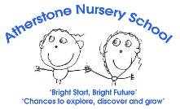
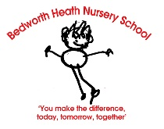
Caterpillar Nursery Long Term overview 2026-27

 | PSED | C&L | PD | Literacy | Maths | UtW | EA&D
Theme | Me in My World - All About Me!
Autumn 1  Starting points and spotlights  met/  not met | Begins to settle into Caterpillar Nursery.  Separates from carer with encouragement.  Begins to engage with others through gestures, gaze and talk.  Knows their name.  Like to do things for themselves.  Show emotions and seek comfort from a trusted adult. | Listen and respond to a simple instruction.  Anticipate next word or action in a song.  Begin to put two words together, eg ‘More milk.’  Begins to ask questions.  Repeats words and finds objects on request | Large body movements, such as waving, rolling, crawling and walking.  Clap hands and stamp feet to music.  Climbs over objects.  Climbs stairs.  Uses a spoon or fork. | Listen to simple stories and look at the pictures to begin to understand what is happening.  Enjoys songs and rhymes. | Takes part in finger rhymes and number songs.  Explore natural materials to notice similarities and differences, eg Autumnal objects – different sized leaves.  Find their way around the environment. | Use their senses to explore the world around them. Notice and explore the different weathers and changing season – Autumn.  Make sense of space and environment through small world trains and cars.  Our family and who I live with at home. How some people celebrate Diwali. | Responds to familiar songs and rhymes.  Build with a range of resources.  Explore paint with hands.  Use role play to recreate known experiences.
By the end of the term most children  will know or have heard:  (knowledge) | The routines of Caterpillar Nursery.  Which adult to seek for comfort and help. | Know and say approximately 50 words. | How to move their bodies for different purposes. | The Nursery Rhymes:  Twinkle Twinkle…  Baa Baa Black Sheep  ‘Hello Song’  5 Little Leaves  Wheels on The Bus | The number songs:  All the Leave are Falling Down.  Five Little Leaves So Bright Today. | The name of different weathers.  Some people celebrate Diwali. | Begin to sing a few words.
Developed these skills: | Solitary Play. | Know more words.  Put two words together.  Listen and respond. | Climb over objects.  Core strength. | How to hold a book and turn the pages.  Preliterate mark making  Pencil grip 1. | Noticing and exploring all around.  Matching. | Scooping and digging sand.  Pouring, filling, emptying | How to build by placing or stacking.  Begin to recreate experiences through role play. Painting
Know and use this vocabulary: | Hello, Mummy, Daddy other family members.  Key person names.  Friend, share, take turns, kind, smile, wait, together time, snack time, wash hands, sit down, room names | Listen, quiet, loud.  More, gone, go.  Car, ball, drink, coat, | Arms, legs, climb, dance, move, listen  Eat, nappy, toilet, potty.  Up, down, in, out. | Story, pictures, song, rhyme, Nursery Rhymes. | Some number names 1-5 – counting for ordinality.  Noticing words, eg big, little, small. Fat, thin. | Rain, sun, cloud, cold, rainbow, wind, frost, snow  Hot, moon, light, colour | Play, house, tea set, kitchen, drink, cup, spoon.
Know these stories or have shared these books: | 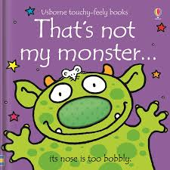  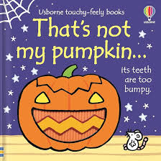  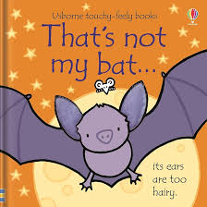  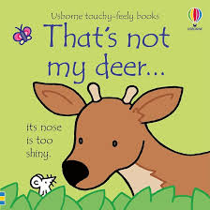  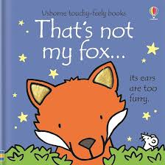  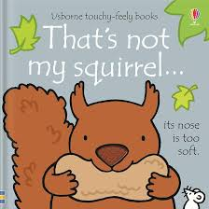  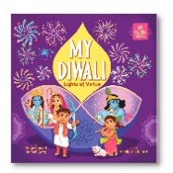  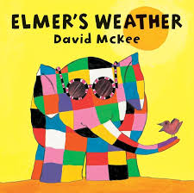  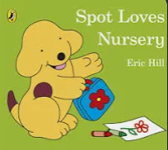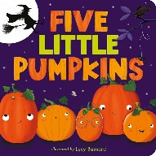



Caterpillar Nursery Long Term overview 2025-2026
 | PSED | C&L | PD | Literacy | Maths | UtW | EA&D
Theme | Changes and Celebrations – Autumn, Diwali and Christmas!
Autumn 2  Spotlights  met/  not met | Continue to settle within the Caterpillar environment.  Play with increasing confidence on their own and with other children, because they know their key person is nearby and available.  Beginning to show an awareness of bladder and bowel movements. | Begin to understand longer sentences, eg, ‘Find your coat’.  Understand simple questions about ‘who’, ‘what’ and ‘where’  Listens and responds to different sounds in the environment.  Begin to put 2 or 3 words together. | Walks and runs over different level surfaces – eg outside obstacles.  Climbs stairs, with both feet on each step eg on slide.  Holds tools with thumb and all fingers.  Uses a spoon or fork.  Holds a cup with two hands.  Take off simple clothes, eg hat. | Say some of the words in songs and rhymes.  Enjoy sharing books with an adult and responds to the pictures or the words.  Have favourite books and looks at books independently.  Repeat words and phrases from familiar stories.  Enjoys making marks on paper, in sand, foam etc. | Begin to compare amounts and recognise when the same or different.  Make simple constructions.  Complete simple jigsaw and peg puzzles.  Explore differences in weight and size.  Explore toys from different viewpoints. | Use senses and talk about things they observe all around them – in the sky, weather, plants.  Small world reconstruction, eg farm, doll’s house.  Their family and families of others.  How some people celebrate, eg Bonfire Night, Children in Need, Christmas. | Join in with songs and rhymes.  Move and dance to music.  Explores sounds by tapping, banging etc.  Explore building – stacking.  Explore drawing and enclosing.  Imitate everyday actions through role-play.
By the end of the term most children  will know:  (knowledge) | The routines of Caterpillar Nursery.  Other children to play alongside.  Which adults to seek for comfort and help. | How to stop and switch attention to listen. | How to travel safely along different heights and surfaces. | Heard the Nursery Rhymes:  Incy Wincy Spider  Head Shoulders Knees and Toes  5 Cheeky Monkeys  Wide Eyed Owl | When small quantities are the same or different.  How to complete a peg puzzle. | How the weather has changed in the Autumn.  How some people celebrate Bonfire Night and Christmas. | The Christmas Songs:  Santa Got Stuck up the Chimney, Jingle Bells, Twinkle Twikle…and know the actions to join in.
Developed these skills: | Solitary play and begin to Play alongside peers – onlooker play | Responding to an instruction.  Listening skills.  Say 2 word phrases. | Climbing and balancing.  Moving their body safely.  Fine and gross motor. | Preliterate mark making  Pencil grip 1. | Constructing  Matching  Comparing | Observing, touching, listening to explore.  Placing and attaching tracks. | Saying and singing.  Swaying and stamping.  Building by stacking and placing horizontally.
Know and use this vocabulary: | Now, next, wait, my turn, your turn.  Friend, share. | I, me, mine, my, you. | Arm, legs, feet, dance, move, climb.  On, off | Owl babies story vocabulary: owl, mummy, come back, tree, ivy, branch, Sarah, Percy, Bill, Mother.  Soft, hard, wet, dry, book, picture. | Some number names 1-5 – counting for ordinality.  More, lots, same, less  Heavy, light. | Farm animal names.  Pumpkin, seeds, stripy, orange, peduncle.  Autumn, cold, rain.  Bonfire, fireworks, Diwali  Christmas, tree, baubles, candy cane, lights. Mary Joseph, Jesus, donkey, camel, Nativity. | Play, house, kitchen, tea set, baking tray, scales, gingerbread man cutter.  Tap, bang.
Know these stories or have shared these books: | 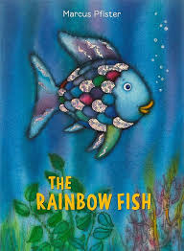  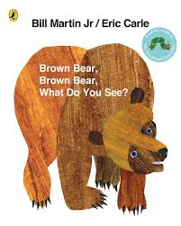  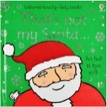  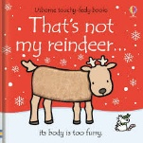  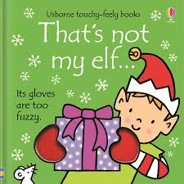  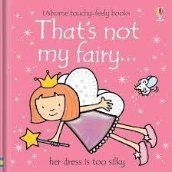  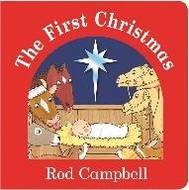

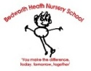
Caterpillar Nursery Long Term overview 2025-2026

 | PSED | C&L | PD | Literacy | Maths | UtW | EA&D
Theme | Me in My World – All About Me and Winter changes!
Spring 1  Starting points and spotlights  met/  not met  Key:  Our returners: existing children returning to Caterpillar Nursery. | Watches what friends are doing and begins to play next to them.  Notice what adults do and begins to help.  Shows more independence, sometimes rejecting help, ‘Me do it.’  Expressing different feelings -sometimes feelings of frustration.  Helps to wash hands.  Growing awareness of bladder and bowel movements. | Is interested in listening to stories read or retold, especially different voices or noises.  Able to stop what they are doing to listen, shifting attention.  Understand simple concepts, eg fast, slow.  Uses lots of new words learned.  Beginning to use: me, I and you. | Run, change direction and slow down so they don’t bump into things.  Fit themselves into spaces, like tunnels, dens and large boxes, and move around in them.  Enjoy starting to kick, throw and catch balls.  Can make lines and marks. | Shows interest and enjoyment in books and stories.  Joins in with songs and rhymes, copying sounds, rhythm, tunes and tempo  Enjoys drawing freely.  Pencil grip 1. | Listen to number songs.  Compares amounts using words such as lots, more and same.  Complete an inset puzzle.  React to changes of amount in a group of up to three items.  Compare amounts, saying ‘lots’, ‘more’ or ‘same’.  Understand the pattern of the day. | Use all their senses in hands-on exploration of natural materials.  Winter and ice investigation.  Imitating family events, eg in the house.  Understand how some people celebrate events, eg Chinese New Year.  Build construction meaningful to them in their environment, eg houses.  Technology to transport – pipes, funnels etc. | Join in with songs and rhymes.  Move and dance to music.  Explore building – stacking a tower.  Explore drawing and enclosing.  Explore paint, using fingers and other parts of their bodies as well as brushes and other tools.  Imitate everyday actions through role-play.
By the end of the term most children  our returners  will know:  (knowledge) | How to try things for themselves to gain more independence. | New words and can use pronouns when talking. | How to move their bodies to negotiate around some obstacles. | The Nursery Rhymes:  ‘Hello Song’ ‘12345 Once I caught a fish…’ ‘Wind the Bobbin up’.  The story, ‘We’re Going on a Bear Hunt.’ | How to complete a puzzle.  Recognise when small quantities are different. | The weather is colder in the winter. Ice is cold and can be melted. | How to create marks with paint and drawing materials.
Developed these skills:  our returners | Play alongside peers – onlooker play  Express. | Hearing sounds and distinguish where they come from. | Moving at different speeds.  Attempt to catch a ball.  Positional awareness. | Pencil grip 1.  Preliterate mark making | Matching to complete an inset puzzle.  Comparing. | Observing, touching, listening to explore.  Filling and emptying | Paint printing with different tools.
Know and use this vocabulary: | I do it. My turn.  Happy, sad. | I, me, my, mine.  You | Catch, throw, ball.  Over, under | Hello Song. Pull, clap, stomp.  Story vocabulary: long wavy grass… | Lots, more, same. | House, home, family. Winter, water, full, cold, ice, frost, snow, snowman.  Chinese New Year, chop sticks, lantern. | Paint, print, brush.  Move and stop.
Our new starters will… | Begin to separate with encouragement and begin to know Caterpillar routines. | Begin to listen to an instruction and put two words together. | Make large body movements and clap and wave. | Listen to and enjoy songs and begin to listen to a short story. | Take part in finger rhymes and notice the environment around them. | Use senses to explore the world around them and make sense of place through small world play. | Respond to familiar rhymes and explore paint, construction and role-play.
Know these stories or have shared these books: | 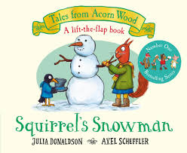  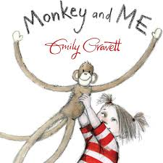  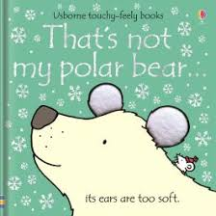  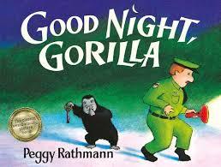  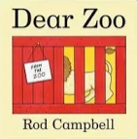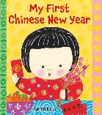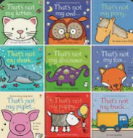

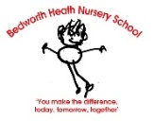
Caterpillar Nursery Long Term overview 2025-2026

 | PSED | C&L | PD | Literacy | Maths | UtW | EA&D
Theme | Springtime – Changes and Easter!
Spring 2  Spotlights  met/  not met | Watches what friends are doing and begins to join in the play.  Has preferences and makes choices.  Turn taking – beginning to show awareness and show control in waiting for a turn.  Shows empathy, and make take a toy to anther child.  Attempts self-care, and may show signs of toilet training. | Understand complex sentences and 2-part instructions.  Uses language to express their feelings, want and needs.  Say a longer sentence of 3 words.  Join a back and forth conversation with an adult, although might jump from topic to topic.  Asks questions, who, what, where.  Rapid development of word vocabulary. | Experiment with moving in different ways, eg slithering, sliding.  Body tension activities, eg stretching, twisting, curling etc.  Explore different tools to achieve new effects, eg hammer and nails. | Ask questions about the book. Make comments and shares their own ideas about a story.  Enjoy and celebrate World Book Day.  Continues play around a story using props.  Enjoys mark making.  Pencil grip 1 or 2. | Listen and join in with number songs.  Compare sizes, weights etc. using gesture and language - ‘bigger/little/smaller’, ‘high/low’, ‘tall’, ‘heavy’.  Know the pattern of the session and anticipate what happened next. | Use senses to explore the world around.  Experience the changing weather and spring season. Notice the changes in the garden – butterflies  How some people celebrate events important to them – Mother’s Day, Red Nose Day. Easter.  Build construction meaningful to them in their environment, eg small worlds relevant to them.  Explore technology by pressing and dragging – IWB. | Sings and responds to music. Explore a range of sound makers and instruments and play them in different ways.  Explore building with a variety of stacking constructions.  Start to make marks intentionally.  Start to develop pretend play, pretending that one object represents another. For example, a child holds a wooden block to her ear and pretends it’s a phone.
By the end of the term most children  will know:  (knowledge)  our returners | Their peers play alongside. At times they have to wait for a turn. | How to follow an instruction.  How to use words in a longer sentence. | How to move their body in different ways.  How to stretch and hold a balance. | The Nursery Rhymes: ‘Old Macdonald Had a Farm’ ‘Hop Little Bunnies..’ ‘Chick Chick..’  ‘Hot Cross Buns’. ‘I dig my garden’ | The pattern of the session, to anticipate now and next.  Items have different weights. | That plants grow in the garden. Watering helps them grow. A caterpillar changes to a butterfly.  How some people celebrate Easter. | How to make different sounds.  How to make marks.
Developed these skills:  our returners | Play alongside peers – onlooker play. Begin to parallel play.  Interact. | Converse.  How to ask a question. | Moving on their feet and other body parts.  Control. | Story telling.  Pencil grip 1.  Preliterate mark making | Comparing and measuring.  Say number names. | Watering and caring for plants.  Observe. | Stacking.  Imitating vertical and horizontal lines.
Know and use this vocabulary: | My turn. Share.  Please, thank you, sorry. | Who, what, where | Slow, fast.  Move, slither, slide. | Book, story pages, front, cover, illustration, back.  Story vocabulary | Big, small, bigger, smaller,  Heavy, light. | Caterpillar, butterfly.  Easter, Easter Eggs, hot cross buns. Spring. Baby animal names. | Music, hop, spin, beat, rhythm, sing.  Shake, loud, quiet.
Our new starters will… | Continue to settle and grow in confidence, knowing their key person. | Understand and use longer sentence and put 2 or 3 words together. | Walk and run over different surfaces and hold tools with thumb and all fingers. | Say some of the words in a rhyme and listen to a story. | Begin to compare amounts and enjoy peg puzzles. Explore weight and size. | Use senses to explore changing weather and take part in small world play. | Explore instruments and movement to music. Make marks, drawing and enclosing.
Know these stories or have shared these books: | 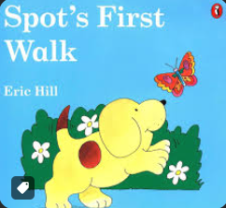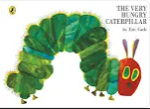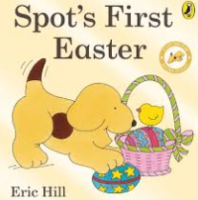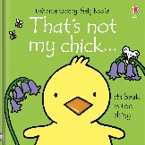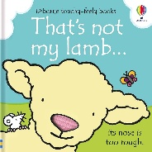



Caterpillar Nursery Long Term overview 2025-2026

 | PSED | C&L | PD | Literacy | Maths | UtW | EA&D
Theme | Me in My World - All About Me and Planting in the Garden!
Summer 1  Starting points and spotlights  met/  not met  Our returners: existing children returning to Caterpillar Nursery. | Beginning to learn that actions have consequences.  Develop friendships with other children.  Respond to the feelings of others, and may notice is someone upset.  Attempts self-care, and may show signs of toilet training. | Use some descriptive language.  Use language associated with:  time – now, later  space – over there  function – a sponge washes. | Obstacle courses and opportunities to travel in different ways.  Upper body skill workouts, sweeping, painting etc.  Growing independence dress or undress. | Enjoys listening to stories read by others.  Looks at books independently.  Enjoy drawing freely.  Pencil grip 1 or 2. Add some marks to their drawings, which they give meaning to. For example: “That is mummy.”  Make marks on their picture to stand for their name. | Join in with number songs and listen to number stories.  Notice patterns and arrange things in patterns.  Play with shapes, noticing when they are the same and different.  Make constructions.  Subitise 1, 2 and 3 in everything all around us. | Use senses to explore the world around.  Notice the changes in the garden – planting, growing and caring for plants.  Explore their environment through small worlds, cars, trains etc.  Explore technology by pressing and dragging – IWB. | Explore a range of sound makers and instruments and play them in different ways.  Build independently with a range of appropriate resources and collage materials.  Express ideas and feelings through making marks, and sometimes give a meaning to the marks they make.  Explore colour with paint.  Use resources in pretend play. Use language to keep play going.
By the end of the term most children  will know:  (knowledge)  our returners | Actions have consequences.  That others have and show different emotions. | More words, particularly adjectives. | How to travel in, around, under and over safely. | The Nursery Rhymes:  ‘Hello Song’ ‘Five Little Speckled Frogs’.  ‘Tiny Tim’. | How to make arrangements with shapes and patterns.  Number names. | The names of some flowers and vegetables growing in the garden. How to care for them. | How to play an instrument to make a sound.
Developed these skills:  our returners | Play alongside peers – onlooker play. Begin to parallel play. | Saying phrases with 2 or more words. | Travelling and moving safely and with increasing control.  Crossing the midway point.  Spatial awareness. | Mark making with vertical, horizontal and circle patterns.  Pencil grip 1 or 2.  Mark making for meaning | Subitise 1 and 2.  Patterns  Sorting  Joining | Sowing seeds. | Drawing, enclosing shapes.  Colour exploration  Joining
Know and use this vocabulary: | Feelings – happy, sad, angry. | Now, next, later, | In, out, move.  Jump, roll. | Story vocabulary… Beanstalk, axe, harp, giant. The end. | Tall, taller, long, short.  Pattern, wavy, curly, straight. | Beans, carrots, sunflowers, seeds, flower, soil, water, dig, grow, beanstalk, press | Collage, colours, layer.  Mix, join, sound, instrument.
Our new starters will… | Begin to separate with encouragement and begin to know Caterpillar routines. | Begin to listen to an instruction and put two words together. | Make large body movements and clap and wave. | Listen to and enjoy songs and begin to listen to a short story. | Take part in finger rhymes and notice the environment around them. | Use senses to explore the world around them and make sense of place through small world play. | Respond to familiar rhymes and explore paint, construction and role-play.
Know these stories or have shared these books: | 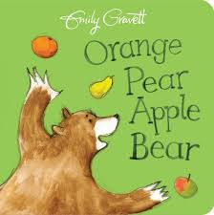  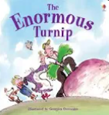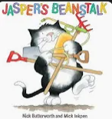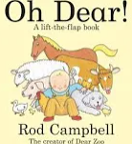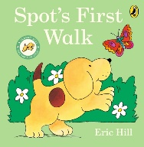
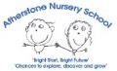

Caterpillar Nursery Long Term overview 2025-2026

 | PSED | C&L | PD | Literacy | Maths | UtW | EA&D
Theme | Me in My World – Summertime and Growing!
Summer 2  Spotlights  met/  not met | Joins in with a collaborative game.  Enjoys the company of other children and may seek the company of children to join their play.  Learn to use the toilet with help, and then independently. | Follow instructions with three key words like: “Can you wash doll’s face?’  Understand action words by pointing to the right picture in a book, eg ‘Who is running?’  Say around 300 words.  Say a sentence linking up to 5 words.  Begin to us pronouns ‘me’, ‘him’, ‘she’.  Show awareness of prepositions ‘in’, ‘on’, ‘under’ ‘behind’– although may not always be used correctly. | Gross motor opportunities to develop balance and core strength.  Upper body, shoulder and elbow strengthening activities.  Fine motor – drawing, chalking, painting on a large and small scale.  Self-care, begin to communicate when hungry, thirsty etc.  Recognise danger and seek an adult to help.  Small motor skills to do things independently, for example manage buttons and zips, and pour drinks. | Enjoys listening to stories read by others and joins in with repetitive refrains.  Looks at books independently, carefully turning the pages and ‘reads’ a story by talking about the pictures.  Enjoy drawing freely.  Pencil grip 1 or 2. Add some marks to their drawings, explaining what is is or drawn.  Make marks on their picture to stand for their name. | Join in with number songs and listen to number stories.  Sort using 1 criteria. Continue a sorting pattern.  Notice and describe similarities and differences in found objects. Language or same, different. More, less.  Subitise 1, 2 and 3 in everything all around us. | Use senses to explore the world around. Experience the changing weather and summer season.  Caring for the allotment.  Explore minibeasts.  How some people celebrate events important to them – Father’s Day, holidays.  Small worlds relevant to them, houses and school. Transition to Butterfly. | Joins in with songs and music. Explores how to change the speed and volume.  Build independently with a range of appropriate constructions and loose parts.  Stack and balance. Begin to enclose.  Use imagination in role-play, seeking others to join in their play.
By the end of the term most children  will know:  (knowledge)  our returners | How to take turns in a game with an adult helping. | How to follow a 3 key word instruction.  Approximately 300 words. | How to balance with more control. | The Nursery Rhymes:  Baa Baa Black Sheep, Head, Shoulders, Knees and Toes. The Finger Family. | How to sort according to a property.  How to recognise a group of 1, 2 or 3. | The names of vegetables planted and how to care for them. Minibeasts found in the garden. | How to build with different construction kits.
Developed these skills:  our returners | Parallel play. | Listening and responding.  Say pronouns, plurals and prepositions. | Shoulder and elbow pivot strength.  Undoing zips and buttons. | Pencil grip 1 or 2.  Mark making for meaning | Sorting by 1 or 2 criteria.  Recall. | Sowing and caring for seeds. Watering. | Stacking, balancing and enclosing.
Know and use this vocabulary: | ‘Can I Play?’ | Me, he, she, I  In, on, under, over | Hungry, thirsty.  Hop, skip. | Beginning, front cover. Story vocabulary, ‘Fee Fi Fo Fum’. | Same, different, more, less. Subitise  Groups of 1, 2, 3. | Vegetable names  Tall, short, taller, shorter  Minibeast names. Sand, sea, beach | Build, stack, enclose, balance.  Rhythm.
Our new starters will… | Continue to settle and grow in confidence, knowing their key person. | Understand and longer sentence and put 2 or 3 words together. | Walk and run over different surfaces and hold tools with thumb and all fingers. | Say some of the words in a rhyme and listen to a story. | Begin to compare amounts and enjoy peg puzzles. Explore weight and size. | Use senses to explore changing weather and take part in small world play. | Explore instruments and movement to music. Make marks, drawing and enclosing.
Know these stories or have shared these books: | 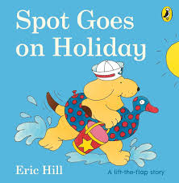  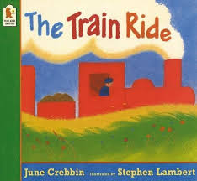  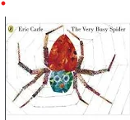
Additional Key Information
Woven throughout our curriculum are:

Characteristics of Effective Teaching and Learning: Playing and Exploring, Active Learning, Creating and thinking critically.
British Fundamental Values: democracy, rule of law, individual liberty, mutual respect and tolerance for those with different faiths & beliefs

Pencil grip 1,2,3,4
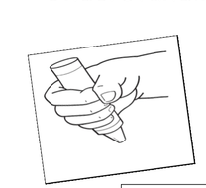 grip 1 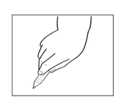 grip 2 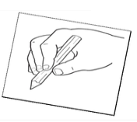 grip 3 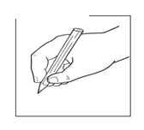 grip 4
Progression of play:
Unoccupied Play (3m -2yrs)
Movements that children make, often with no clear purpose.

Solitary Play (3m -2yrs)
Children start to play on their own. Children not seem to notice other children nearby.

Onlooker Play (2.5 yrs)
Children watch others play. The child who is looking may ask questions, but does not join in the play.

Parallel Play (2.5 – 3.5 yrs)
Children begin to play side by side, but without any interaction. They are paying attention to each other.

Associative Play (3-4 yrs)
Children start asking questions of each other. They have similar goals, but no set rules.

Social Play (4-6 yrs)
Children begin to share ideas and toys, and follow established rules.
Progression of Writing patterns:

*To support the development of pencil grip and writing patterns, we plan sequentially across the year:
Flipper Flappers,
Write Dance,
Dough Disco.

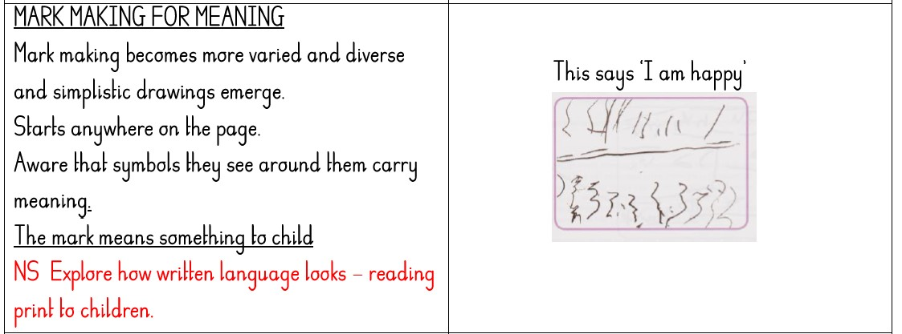
Mark making for meaning
(More varied shapes. Begin to say what they have written.)

Initate a vertical line and horizontal line.
2.5 yrs
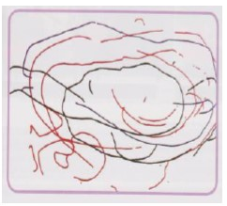
Preliterate mark making
(No intentional meaning)

Random and spontaneous in vertical, horizontal and circular motions.
2 yrs
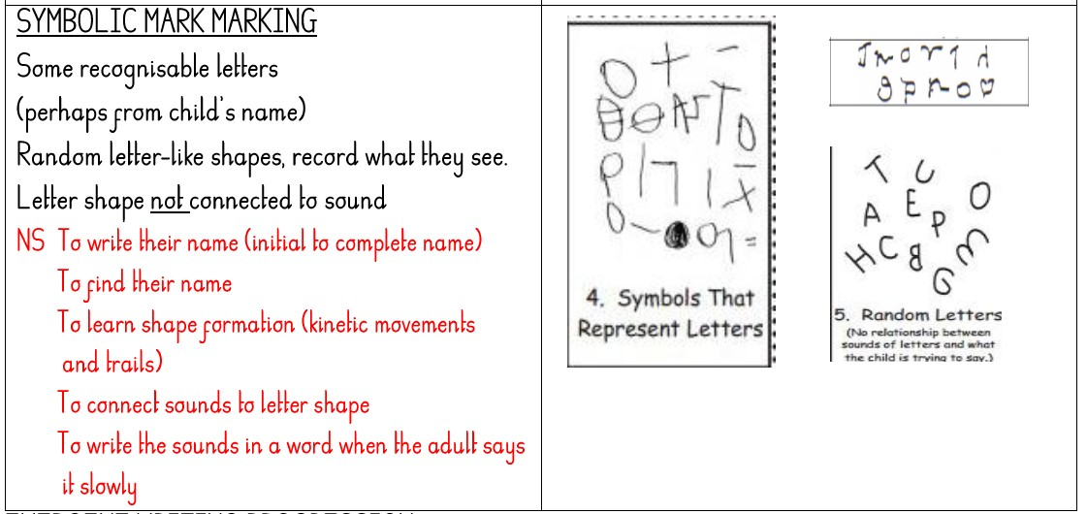Symbolic mark making
(Attempting letter like shapes, but not linking to sounds.)
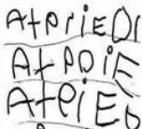Emergent writing
(Symbols they know the sounds they make. Mostly from name.)

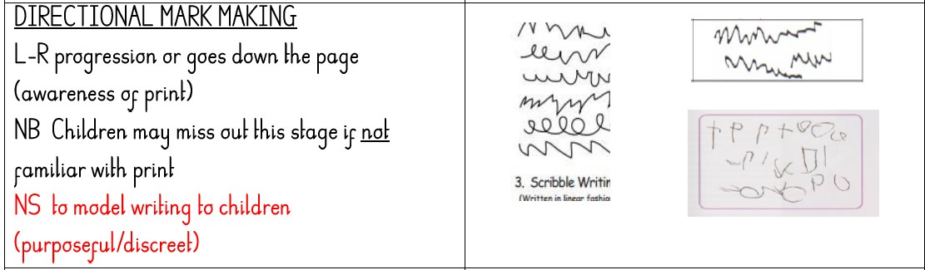Directional mark making
(Shapes that may be written across the page.)

Progression of Scissor/Cutting Skills:

2 Years  Approximate age | Cutting dough/ cooked pasta | 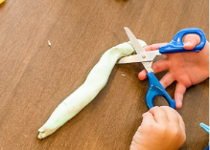
2.5 Years  Approximate age | Cutting snips on paper | 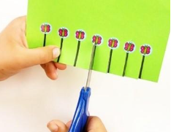
3 Years  Approximate age | Cutting a straight line | 
3.5 Years  Approximate age | Cutting a curve line or circle | 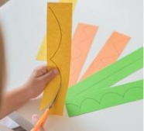
4 + Years  Approximate age | Cutting a square | 
Progression of Scissors:
Plastic Playdough Scissor | 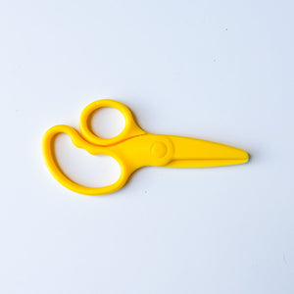
Loop Scissor | 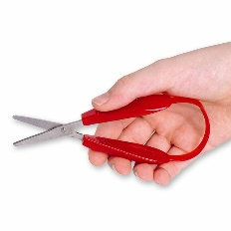
Spring Back Scissor | 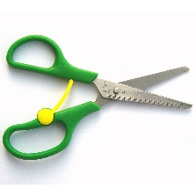
4 Holed Scissor | 
Non-spring Scissor | 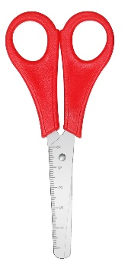
Patterned Scissor | 