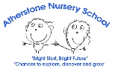

Butterfly Nursery Long Term overview 2026-27
 | PSED | C&L | PD | Literacy | Maths | UtW | EA&D
Theme | Me in My World - All About Me
Autumn 1  Starting points and spotlights  on track/  not met | Begin to share and take turns.  Select activities and resources, with help.  Understand routines of Nursery.  Gaining toilet control  Wash and dry hands.  *Protective Behaviours – my body and body names | Listen in small groups.  Respond to a one or two part instruction.  Use vocabulary based on their experiences. | Gross motor  Walk and run comfortably.  Climbing equipment.  Balance bikes  Large scale movements, pens/paint on wallpaper.  Fine motor  Begin to show a dominant hand.  Begin to use tools eg scissors. | Join in with Nursery rhymes  Explore books, carefully and correctly.  Independent Mark making.  Hear environmental sounds. | Counting for ordinality - number songs.  Noticing, comparing and communicating – natural objects and patterns.  Using number names in play.  Playing with and making arrangements with shapes. | Observation and use of senses - Talk about things they have observed- natural objects.  Autumn – How weather changes and observations linked to this  Harvest.  Features of their familiar world – train/cars/house small world  Talk about themselves, family and special times. | Take part in some Nursery Rhymes and action songs.  Explore and use a range of construction materials.  Explore a variety of textures – paint, playdough, collage  Independent mark making  Imaginative role-play based on first hand experiences – role play & small world
By the end of the term most children  will know:  (knowledge) | The rules and routines of Butterfly.  Some children’s names.  How to begin to interact with new peers. How to wash and dry hands.  Use visual prompts to be more independent when going to the toilet.  Knowing where/looking after belongings their own and nurseries. | How to show their body is ready for good listening and learning, eg ‘being quiet’, ‘good looking’, keeping their hands to themselves so not to distract others.  How to use vocabulary and talk to express their wants and needs, eg ‘I need the toilet’ | How to walk safely, trying to negotiate spaces and obstacles.  How to make large movements with shoulder pivot to develop upper body strength.  Which hand to use for writing. How to hold a pencil and mark make.  Attempt to hold scissors and snips. | How to hold a book and turn the pages.  How to listen to stories read by others.  Know and say the Nursery rhymes: Incy Wincy Spider, Humpty Dumpty, Baa Baa Black sheep,Twinkle Twinkle Little Star, The Wheels on the bus.  Listen to quiet, loud and environmental sounds. | Number names in order 1-5.  How to sort by one criteria – noticing similarities and differences.  How to select shapes appropriately when constructing. | It is Autumn, and name some changes: leaves change colour and fall from trees.  How natural, found objects feel, smell, look, taste and sound through independent exploration  Talk about who they live with at home and their family.  How to make sense of their own life-story and family’s history by talking about birthdays, family events | Sing some Nursery rhymes and action songs.  Begin to access different techniques in creative activities – collage, paint, colour, glue.  How to colour mix with hands  How to stack construction bricks.  How to use imagination in the Home Corner e.g. pretend to cook dinner.
Developed these skills: | Play alongside peers -onlooker and parallel play  Sharing.  Wash and dry hands.  Adjust clothes to sit on the toilet.  Flush the toilet. | Quietness for a short time to be able to listen.  Understand and respond to an instruction that has one or two parts.  Listen to short stories. | Pencil grip 1 Most likely whole hand grasp.  Make snips in paper with scissors.  Climb with alternate feet,  Scoop food using a fork or spoon at lunchtime. | Preliterate mark making Hold a book correctly.  Mark make using pens, pencils, paint, brushes  Describe sounds they can hear in the environment. | Rote counting/counting for ordinality.  Noticing patterns in the environment. | Use of senses to explore.  Speak about themselves and their family. | Use a glue stick by twist and turn the bottom.  Colour mix with hands.  Stack construction bricks to build and balance.
Know and use this vocabulary: | Share, take turns, wait.  Body part names -Protective Behaviours. | Listen  Quiet, loud | Wash hands  Hold  Scissors, snip, cut,  (“open, close, open, close”)  Coat – off/on/hang up | Recite the above Nursery Rhymes.  Loud, quiet, sounds | Number names (1-5)  Notice  Same different  More, less  Flat, round | Autumn, weather, drizzly, dark, damp, cloudy, wet, rainbow Changing colours – green, yellow, brown, orange, red  Autumn objects - Leaves, pine cones, crunch, crisp, rustle, conkers, acorns, squirrel, hedgehog, owl night time animals (nocturnal) Harvest. | Texture - soft, hard, smooth, bumpy, shiny  Paint brush, glue, sellotape, scissors, cut  Colour and colour names.  House, washing machine, cooker, knife, fork, spoon, dinner,
Our rising 3s will… | Begin to understand the routines with additional adult support and visual prompts.  Engage in onlooker play.  Show signs of toilet training. | Listen for a shorter time.  Respond to a one part instruction.  Say a few words with developing pronunciation. | Climb with two feet.  Use a balance bike – not pedals.  Show interest in using mark making tools. | Imitate vertical and horizontal lines, loops, dots and circles.  Listen with support and begin to join in with some words of a nursery rhyme. | Notice and begin to name natural objects, eg shells, sticks, stones. | Use senses to explore and begin to name what is observed in Autumn, eg yellow leaves. | Use imagination to recreate own experiences, eg pour tea, pretend to use the telephone.  Show interest in loose parts and exploring paint.
Know these stories or have shared these books: | 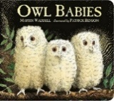  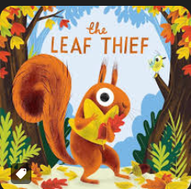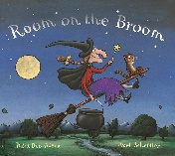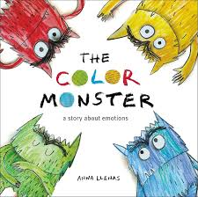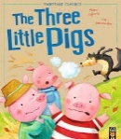
 | PSED CL PD Literacy Mathematics UtW EaD
Theme/Texts | Changes and celebrations – Autumn, Bonfire Night, Remembrance Sunday, Our feelings, Christmas
Autumn 2 | Begin to initiate play and keep play going.  Select activities and use resources, with help.  Gaining toilet control and attending to needs.  Put on coat and apron.  Begin to understand emotions.  *Protective Behaviours – my feelings. Safe and unsafe touching. | Listen to stories and begin to join in.  Respond to one or two part instructions.  Build new vocabulary.  Use talk to explain and relive. | Gross motor  Walk and run comfortably.  Climbing equipment.  Large scale movements, Mount stairs and climbing equipment  Fine motor  Begin to show a dominant hand.  Begin to use tools with control. | Enjoy rhyme and rhythm in words.  Phonics - Hear and identify environmental sounds. Listening and attention games, eg ‘What’s inside the box?’  Listen and begin to respond to stories.  Independent mark making, beginning to give meaning to marks. | Counting for ordinality - number songs.  Noticing, comparing and communicating – natural objects and patterns.  Perceptual subitising to 3.  Using number names in play.  Playing with and making arrangements with shapes.  Develop comparative language – heavy, light.  More, less, fewer, same.. | Observation and change. Use senses to explore the changing weather/season/light/dark.  Talk about significant events, using time vocabulary – Diwali. Halloween, Bonfire Night, Christmas. Remembrance Sunday. Children in Need.  Shows interest in technological toys or real objects – phones. | Learn and sing new songs.  Describe the different sounds instruments make.  Explore how to change the sounds of instruments.  Use construction to stack and balance.  Explore colour mixing with hands. Using imagination to develop stories in role play and small world.
By the end of the term most children will know: | How to begin play with a peer.  How to join in and continue their play.  How to access resources independently and use for their own purpose.  How to attempt to put their coat & apron on independently. | The stories, ‘Rama and Sita’ ‘The Three Little Pigs.’ ‘The Colour Monster’ ‘The Nativity’.  Describing words to describe Fireworks. | Can use one handed tools with some control, e.g. scissor snipping, glue stick spreading.  Refined gross motor skills – balance, climb using alternate feet.  Using preferred grip, how to use a pencil or chalk to make marks  Eat their lunch using a fork independently | The events in the stories, ‘The Three Little Pigs’ ‘Rama and Sita’ ‘The Nativity’.  Know we read from left to right, top to bottom.  Know /say the Nursery Rhymes  Miss Polly had a Dolly  Wind the bobbin up  1 2 3 4 Once I caught a fish Alive Hickory Dickory Dock | Number names in order 1-5.  How to sort by one criteria – noticing similarities and differences.  How to select shapes appropriately when constructing. | How people celebrate  That some people celebrate Diwali, Bonfire Night and Christmas.  The changes that occur during Autumn.  Have a sense of time, yesterday, long ago.  Materials - Some names of different materials: straw, sticks, bricks, wood. | How to change the sound of an instrument, e.g. make it louder or quieter.  Use different materials and techniques to develop ideas.  How to create closed shapes with continuous line.  How to pretend to be someone different in imaginative play.
Developed these skills: | Play alongside peers -onlooker and parallel play  Wash and dry hands.  Adjust clothes to sit on the toilet.  Flush the toilet.  Use toilet with greater independence. | Understand an instruction that has two parts, such as “Get your coat and wait at the door”.  Use longer sentences of four to six words with new vocabulary. | Pencil grip 2  Make snips with scissors.  Stab food with a fork.  Use masking tape and glue sticks  Draw lines and circles.  Climb using alternate feet. | Begin to mark making for meaning.  Identify an environmental sound.  Listening and attention – quiet, waiting, anticipation. | Rote counting/counting for ordinality.  Noticing patterns and recognise more/less.  Perceptual subitising 1 and 2. | Use senses to explore changes.  How to make technological toys work, eg press buttons on mobile phones etc. | Creative techniques – sticking, painting, collaging, cutting.  Identifying instruments.  Listen with increased attention to sounds.  In role play will use an object to represent something else.
Know and use this vocabulary: | Help please  Can I play? | Story vocabulary, ‘Little Pig, Little Pig, let me in…’ | Scissors, snip, cut along, “open, close, open, close...”  Tape – peel, stick, cut | Story vocabulary: ‘Little Pig, Little pig..’ ‘I’ll huff and I’ll puff…  Rhyme, alliteration. | More, less, same, fair, many, few, fewer.  Heavy, light, sort. | Pumpkin, seeds, peduncle, Autumn, acorns, pine cones, conkers, leaves. Bonfire, fizz, buzz, bang, whoosh, Diwali, celebration, Temple, Diva lamp, (Time vocab) yesterday, before, now, next. | Different sounds in Home Corner Role-Play – e.g. telephone ringing, oven ping.  Describing sounds – loud, quiet, fast, slow, high, low.
Our rising 3s will… | Understand the routines with additional adult support and visual prompts.  Engage in onlooker play.  Show signs of toilet training | Listen for a shorter time.  Respond to a one part instruction.  Say a short phrase with developing pronunciation. | Climb with two feet.  Use a balance bike – not pedals.  Show interest in using mark making tools. Pencil grip 1 | Imitate vertical/horizontal lines, loops, dots and circles.  Begin to listen for an increased amount of time and begin to join in with parts of a nursery rhyme. | Notice and begin to name and describe natural objects, eg shells, sticks, stones – big, small, bumpy. | Use senses to explore and begin to name what is observed in Autumn, eg yellow leaves. | Use imagination to recreate own experiences, eg pour tea and give to a peer or adult.  Show interest in loose parts and exploring paint.
Know these stories or have shared these books: | 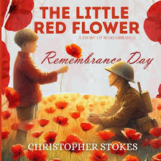  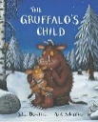  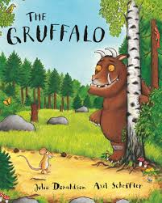  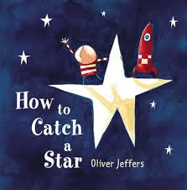  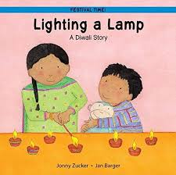  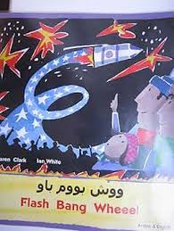  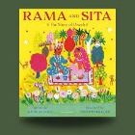  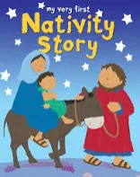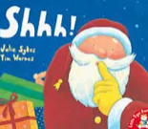
 | PSED CL PD Literacy Mathematics UtW EaD
Theme/Texts | Changes - Winter and stories with repetitive rhymes and rhythms
Spring 1 | Play in a group, beginning to elaborate ideas.  Enjoys small tasks/praise.  Confident to talk to others, talk about home and community.  Begin to accept the needs of others and take turns.  *Protective Behaviours - body parts, unsafe/safe touching, Underpants rule. | Listen to, recall stories and repeating refrains.  Begin to understand prepositions  Begin to use tenses  Build new vocabulary  Use talk to connect ideas, link thoughts.  Begin to question and give explanations understanding how and why questions. | Gross motor  Move their body in different ways, eg along the trim trail.  Negotiate space.  Throw a ball.  Large scale movements,  Fine motor  Pencil control, no longer whole hand.  Scissor and tool control, and understand safety.  Recognise if tired, hungry.  Dresses with help. | Phonics - Enjoy rhyme and rhythm in words. Alliteration.  Hear and identify environmental sounds – animal, household sounds.  Begin to hear initial sounds.  Story sequencing, recall of events, repeated refrains.  Describe story characters and settings.  Recognise, and begin to write name  Independent meaning to marks, Story maps, sequencing. | Counting for ordinality - number songs.  Noticing, comparing and communicating – natural objects and patterns.  Perceptual subitising to 3.  Using number names in play.  Playing with and making arrangements with shapes.  Recognise ‘same’  Begin representations  Positional language  Size | Talk about things they observe – ice melting investigations  Observe and use sense to explore changes in winter.  Comments and asks questions about the familiar world – where they live.  Show interest in the lives of others - Chinese New Year  Know they are unique, and talk about similarities and differences  Operate simple equipment, eg draw on the IWB, bee bots, Ipads | - Tap repeated patterns, using hands, feet, instruments.  Join construction vertically and horizontally. Make enclosures.  Explore colour changing and use of different tools.  Explore drawing - Use line to enclose a space  Explore colour mixing using paint and chalk.  Develop stories in role-play, taking on a different role, and build upon a story in small world play.
By the end of the term most children will know: | How to use sentence starters to interact with peers.  How to complete small tasks, such as washing up.  How to behave, when given praise, what it feels like to feel happy inside.  Know their body boundary and trusted adults. | The key events and phrases in the stories:  ‘We’re Going on a Bear Hunt’  ‘The Three Billy Goats Gruff’  ‘Goldilocks and the Three Bears’ | That we are learning to strengthen our shoulders, elbows, wrists and fingers and that it will help our pencil grip.  How to let go of a ball and begin to throw and catch to self and with a partner. | Know and say the Nursery Rhymes: Jack and Jill, Hey Diddle Diddle, Little Miss Muffet.  How to hear and identify an environmental sound.  The story events, and characters.  The repetitive phrases. | How to perceptually subitise to 3.  Recognising groups of 1, 2 and 3 without the need to count. | Some changes that occur during the winter, eg cold weather, snow, frost, ice.  How to melt and freeze ice.  How some people celebrate Chinese New Year. | How to clap and tap a steady beat.  How to join large construction pieces together to make an enclosure.  That different tools produce different paint effects.  How to explore colour and colour-mixing.
Developed these skills: | Take turns in a game with a few children. | Engage in a conversation.  Listen and begin to join in with a story.  Listen and respond to a question. | Move from whole hand to holding pencil between first 2 fingers and thumb. Pencil grip 2/3 with a dominant hand Cut along a straight line with scissors.  Scoop food with a fork | Mark making for meaning/directional mark making  Clap simple rhythms/syllables in name.  Copy a body percussion sound or pattern of sounds. | Using a five frame to recognise 1, 2 and 3, to ‘move it to prove it.’ | Problem solving and critical thinking – how to melt and freeze ice.  Listening and reasoning. | How to use pencils or pen to enclose a space.  Clap and tap a repeating pattern using instruments.  Adding different colour paints and mixing together to make a new colour.
Know and use this vocabulary: | Sentence starters:  ‘Can you help me Please?’  ‘Can I have it please?’  ‘My turn now, your turn next’. | Story vocabulary: ‘long wavy grass, swishy swashy…  Trip, trap… who’s that trip trapping over my bridge?’ | Shoulder, elbow, wrist, fingers.  Tired, hungry, thirsty.  (Rhyme to put on coat) – “Hood by your foot”  Drop, throw, catch. | Goldilocks and the Three Bears – ‘Who’s been eating…?  Author, character | Number names.  Five frame, same, more, less, fewer, full, empty.  Under, on, in front, behind, next.  Part, whole | Winter, ice, frost, cold, slippery, twinkle, glistening, freezing, melting.  Chinese New Year, celebration, lantern chopsticks. | Steady beat, rhythm. Clap, tap, claves.  Colour mix, splatter paint, drip, drop, pour.  Build, stack, tower, join.
Our rising 3s will… | Follow the routines with additional adult support and visual prompts.  Engage in onlooker and parallel play.  Show signs of toilet training | Listen for a shorter time.  Respond to a one part instruction.  Say a short phrase with developing pronunciation. | Climb with two feet.  Use a balance bike – not pedals.  Show interest in using mark making tools. Pencil grip 1 and 2. | Imitate vertical/horizontal lines, loops, dots and circles.  Begin to listen for an increased amount of time and begin to join in words of a nursery rhyme. | Notice and begin to describe natural objects – long, short, more… | Use senses to explore and begin to name what is observed in Winter, eg cold, ice. | Use imagination to recreate own experiences and use objects to represent something else. Show interest in loose parts and exploring paint.
Know these stories or have shared these books: | 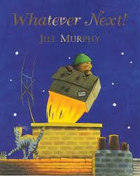  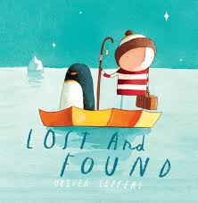  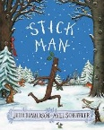  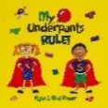  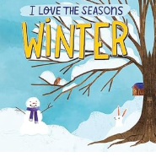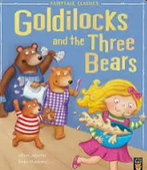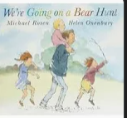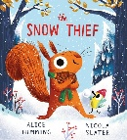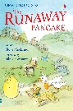
 | PSED CL PD Literacy Mathematics UtW EaD
Theme/Texts | Changes - Spring, Easter
Spring 2 | Play in a group, keeping play going and elaborating  Ask others for help.  More confident in new situations, with new people.  Aware of their own feelings, and those of others. Use talk to resolve conflicts.  *’Big feelings’ and self-regulation strategies. | Listen to a conversation in small groups.  Listen and do.  Understand why and how questions.  Say more complex sentences/retell events.  Connect ideas/anticipate.  Use a wider range of vocabulary.  The conjunctions ‘and’ or ‘but’ and begin to join sentences together. | Gross motor  Move their body confidently and in different ways, negotiating space.  Throw and catch a ball.  Control in jumping and balancing.  Large scale movements,  Fine motor  Scissor and tool control, and understand safety.  Begin to copy their name. | Phonics - awareness of rhyme and alliteration  Begin to hear initial sounds.  Recognise own name.  Predict story endings  Independent meaning to marks.  Name writing | Number names in order 1-10 through counting for ordinality – songs, stories.  Recognise groups of 1, 2, 3 and check on a five frame.  Match to the numerals.  Perceptual subitising to 3.  Explore 4 and 5 on a Five Frame.  Use shapes for tasks, spotting and naming in environment. | Prediction - Develop and understanding of change – butterfly life cycle.  Changes in Spring and in the garden.  Show interest in different occupations and ways of life.  Mother’s Day – how they have changed since being a baby.  Show interest in the lives of others. Know they are unique, and talk about similarities and differences and family events - Easter  Operate equipment IWB games | Movement in response to music  Construction joining and bridging. Junk modelling  Drawing, painting, colour and texture, printing.  Role-play, acting in a role from their wider experience (people who help us role-play).  Use available resources to make props.  Build upon a story in small world.
By the end of the term most children will know: | How to explain their feelings and begin to understand the feelings of others.  Know how to be kind friend, and how words and actions might upset someone.  Know how to be healthy and eg clean their teeth. | How to listen well in a small group.  How to give an appropriate answer when asked a how or why question.  Speak in longer sentences to explain or retell an event.  Say a sentence joined with ‘and’ or ‘but’. | Put on their coat independently, by placing on the ground, ‘hood by foot’ and flipping over their head.  How to negotiate space, by weaving in and out.  How to move their bodies, running, slithering, shuffling, sliding… along the floor and on apparatus. | Hear and say the Nursery rhymes/songs: Polly Put the Kettle on, Five Current Buns, Chick, Chick, Chicken, I’m a Little Teapot, Old Macdonald’.  Developing awareness of alliteration and rhyme.  The initial sound in their name and hear and say initial sounds in words. | Number names in order 1-10.  Groupings of 1, 2 and 3.  Perceptual subitising on a five frame 1-3. Begin to recognise 4 and 5 on a five frame and explain how they know. | The butterfly life cycle.  Some significant events in their family, eg Mother’s Day.  How some people celebrate Easter. | Which instruments made good sound effects to accompany ‘Rosie’s Walk’  Move their body to a piece of music..  How to use imagination and create a junk modelling model.  How to pretend to be a fire officer for instance and the things they will need to do and say in role.
Developed these skills: | Begin to recognise ‘big’ feelings.  Begin to show control. | Begin to express own thoughts and ideas. | Use scissors to cut straight, wavy and zig zag lines.  Hold pencil near point between first 2 fingers and thumb. Pencil grip 2/ 3  Hold knife and fork | Symbolic mark making | Know how many on a five frame by recognising the pattern, eg ‘It’s 5 because the five frame is full.’ | Sequence the butterfly life cycle.  Drawing a picture on the IWB. | Select and play instruments for a purpose.  Join construction to build an enclosure.  Collaborate during imaginative play.
Know and use this vocabulary: | Sentence starters:  Sentence starters:  ‘Would you like to play?’  ‘Can I Play please?’  ‘I don’t like that, please stop.’ | Some questions, what, where, when, why, how.  Hold and say the sentence starter together, eg, ‘Today it is cold, but sunny’  But, and. | Heartbeat, blood pumping, out of breath, hot, sweaty.  Run, hop, balance, slide, slither. | Story vocabulary.  Story, beginning, middle, end. Story setting.  ‘The Very Hungry Caterpillar’ story vocab: Monday, Tuesday… | Empty, full, five frame,  Number names.  Subitise.  Part, whole, share, equal, fair, unfair.  Empty, full, overflowing, half full | Caterpillar, chrysalis/cacoon, emerge, butterfly. Life cycle. Symmetrical. Egg, chick, hen, cockerel, chicken. Easter, Spring, weather, sunny, rainy, rainbows, mild, warmer. Buds, flowers, blossom, baby animals. | Instrument names. Descriptive words to describe the sound, eg swishing, bang, pitter patter.  Junk modelling, cut, attach.
Our rising 3s will… | Follow the routines with adult support  Engage in onlooker and parallel play.  Show signs of toilet training | Listen for a shorter time.  Respond to a one or two part instruction.  Say a short phrase with developing pronunciation. | Climb with two feet.  Use a balance bike – not pedals.  Show interest in using mark making tools. Pencil grip 1 and 2. | Imitate vertical/horizontal lines, loops, dots and circles. Begin to listen for an increased amount of time and begin to join in words of familiar stories. | Use language to describe what they see – long, short, big, tall.  Perceptually subitise 1 and 2. | Use senses to explore and begin to name what is observed in spring, eg flowers, green leaves. | Use imagination to recreate own experiences and use objects to represent something else. Show interest in loose parts and exploring paint.
Know these stories or have shared these books: | 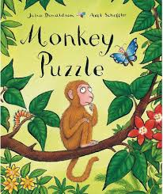  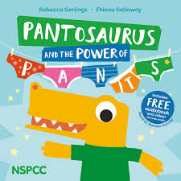  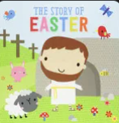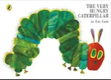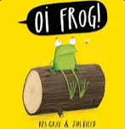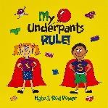
 | PSED CL PD Literacy Mathematics UtW EaD
 | In the Garden
Summer1 | Demonstrate friendly behaviour, initiating conversations, taking account of what others say.  Tolerate delay, and understand wishes are not always met.  Eat and understand healthy foods.  *Network hand – ‘safe people’ | Use longer sentences of four to six words.  Join in a conversation, taking turns to speak.  Use different tenses. | Gross motor  Negotiate space when playing racing games.  Control over throwing and catching.  Control in jumping and balancing.  Large scale movements,  Fine motor  Use tools with increasing control, incl pencil/scissors  Use anticlockwise movements and retrace vertical lines.  Copy recognisable letters. | Phonics - hear initial sounds Oral blending.  Introduce phonemes: s a t p i n .  Begin to form graphemes.  Use vocabulary influenced by books.  Independently give meaning to marks.  Understand information can be found from Non Fiction books.  Recognise and write name. | Perceptual subitising to 3.  Explore numbers to 5 noticing 1 more than.  Match to numerals.  Begin to represent the numbers 1-5.  Use a range of 2D shapes to make pictures and patterns.  Create repeating patterns using natural objects.  Notice and compare size, weight and capacity in play. | Caring for living things and the environment.  Planting and life cycles – Develop understanding of growth and changes – planting.  Notice observations closely using senses.  Complete simple programmes on the computer and I pads. | Play instruments with control to play loud/ quiet, (dynamics).  Combine different media – design and junk model.  Experiment with different materials – crayon…Clay.  Drawing, creating representations and developing preferences.  Introduce a storyline through role-play and small world, using props and making props to support.
By the end of the term most children will know: | How to use a sentence starter to play and cooperate with others.  How to begin to self-regulate when their wishes are not met. | How to retell events in the correct sequence and order.  Past, present, future – played, playing , I will play. | How to adjust speed in racing games.  Where to place their hands to throw and catch with more control.  Some healthy food names. | Hear and say the Nursery Rhymes/songs: Five Little Speckled Frogs, Little Bo Peep, Five Little Ducks, The Wheels on the Bus.  Orally blend.  Begin to recognise s a t p i n | One more than a number 1-5.  Recognise numbers 1-5. | Seeds need soil, water and the sunlight to grow. | How to play instruments with different volumes.  Join construction by stacking and bridging.  How to sculpt with clay.
Developed these skills: | Begin to self-regulate and persist. | Conversing - hold a conversation with an adult or peer, continuing for many turns. | Hold pencil near point between first 2 fingers and thumb, with good control. pencil grip 3 Copy letters from their name. Cut along a wavy and zig zag line with scissors. | Symbolic mark making Emergent writing  Orally blend a cvc word - When practitioner, says the sounds in a cvc word, eg ‘c a t’, children point to the corresponding picture. | Using a five frame to find one more than.  Measure,  Predict | Scooping, digging and planting.  Watering and caring for plants. | Joining and bridging construction to make an enclosure.  Manipulating clay.  Moulding
Know and use this vocabulary: | Sentence starters:  ‘I am feeling…’  ‘How do you feel?’  ‘I am sorry’ | First, next, then, after. | Healthy, unhealthy, balanced diet. Fruit and vegetable names. | Phonemes, new sound, orally blend, letter rhymes.  Fiction, non-fiction/information books.  Blurb, contents. | Subitise, same, more, less, fewer, Part, whole.  1 more than.  “4 is made from 3 and 1. 1 more than 3 is 4.”  Heavy, light, equal to. | Seed, soil, water, sunlight, watering can, plant pot,  Roots, stem, shoot, leaves, flower. | Instrument names.  Volumes, loud, quiet, louder, quieter.  Build, join, enclose, bridge.  Clay, sculpt, pinch, squeeze, press, roll.
Our rising 3s will… | Follow the routines with adult support  Engage in onlooker and parallel play.  Show signs of toilet training | Listen for a shorter time.  Respond to a one or two part instruction.  Say a short phrase with developing pronunciation. | Climb with two feet.  Use a balance bike – not pedals.  Show interest in using mark making tools. Pencil grip 1 and 2. | Imitate vertical/horizontal lines, loops, dots and circles. Begin to listen for an increased amount of time and begin to join in words of familiar stories. | Find groups of 1, 2 and 3 and perceptually subitise. They may explore five frames. | Use senses to explore and begin to name what is observed in the garden, eg | Use imagination to recreate own experiences and use objects to represent something else. Show interest in loose parts and exploring paint.
Know these stories or have shared these books: | 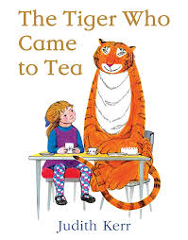  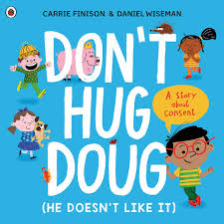  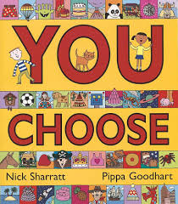  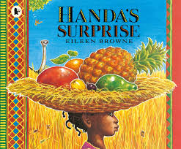  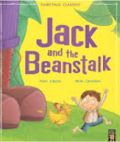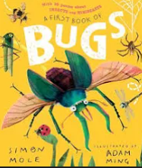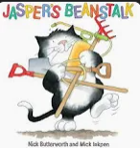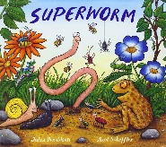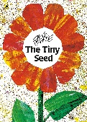
 | PSED CL PD Literacy Mathematics UtW EaD
 | Outside!
Summer2 | Demonstrate friendly behaviour, initiating conversations, taking account of what others say.  Confident to talk to others about wants and needs.  Aware of the boundaries and behavioural expectations.  Being healthy – physical activity and screen time.  Importance of clean and healthy teeth. | Use longer sentences of four to six words.  Join in a conversation, taking turns to speak. | Gross motor  Negotiate space when playing racing games.  Jumping.  Control over throwing and catching.  Fine motor  Use tools with increasing control.  Use anticlockwise movements and retrace vertical lines.  Copy recognisable letters.  Pencil and scissor control | Phonics - oral blending and begin to orally segment.  Hear, say and record initial sounds in words.  Begin to blend to read VC and CVC word containing satpin.  Handwriting - begin to form letters, eg satpin and letters and words of significance.  Use vocabulary influenced by books.  Independently give meaning to marks.  Use identifiable letters, representing some sounds correctly in order. | Conceptual subitising (early addition) adding two quantities and using the five frame to calculate, eg 2+2=4.  Recognise numbers 1-5 and some to 10.  Begin to represent the numbers 1-5.  Explore 2D and 3D shapes and their properties. | A different place - seaside  Caring for living things and the environment. Planting and life cycles – Develop understanding of growth and changes.  Enjoy joining in with family customs, routines -House role-play, small world. Father’s Day  Transition – sequencing  The day, what happened yesterday, today and in the future (new school)  Recognise special events.  Summer – How the weather and the clothes we wear change. Complete simple programmes on the computer and I pads. | Play instruments with control to play fast/slow (tempo).  Combine different media – design and junk model.  Experiment with different materials – pastels,  Clay.  Drawing, creating representations and developing preferences.  Introduce a storyline, create a scenario with a role to play. Collaborate and plan play with a peer, role-play and small world.
By the end of the term most children will know: | A sentence starter to play and cooperate with others. How to begin to self-regulate when their wishes are not met.  How to keep teeth healthy.  Their new school and feelings about transition. | Use talk to express feelings, ideas and events. | How to jump safely.  How to form some satpin letters correctly. | Hear and say the Nursery Rhymes/songs: Row, Row Row Your Boat, One Two Buckle my Shoe, Frere Jacques.  Orally blend and begin to orally segment.  Satpin and begin to read vc and cvc words. Write some initial sounds in words. | How to use a five frame to calculate simple addition. | That seeds need soil, sunlight and water to grow.  That a shoot sprouts from the seed, and grows upwards. That leaves and flowers grow from the stem. | How to play an instrument quickly and slowly.  How to create a picture with pastels.
Developed these skills: | Teeth brushing. | Listening, expressing and responding. | Correct pencil grip 3  Cut with scissors around a shape. Attempt to use both knife and fork | Write their name.  Make recognisable letters.  Emergent writing | Early addition.  Critical thinking and reasoning. | Caring for the allotment. | Pastel techniques.  Collaboration and retelling.  Threading.
Know and use this vocabulary: | Sentence starters:  “I feel …”  “I need to …”  Teeth, gums, toothbrush, tooth paste, dentist, brush, up, down, across, | I am feeling…. about…. |  | Repetitive story refrains.  Initial sound, phoneme, grapheme, blend, segment. | Five frame. Siubitise.  Shape, 2D shape names, Sides, long, short, same, corners. 3D shapes. Sphere, cupboid, cube, cylinder. | Seed, soil, roots, shoot, stem, leaves, flower. Summer weather, hot, humid Seasons, year, change, Seaside, sea, shells, sand, pier, rockpools, lighthouse. | Musical instrument names. Tempo, fast, slow, faster, slower.  Pastels, press, smudge.
Our rising 3s will… | Follow the routines with adult support  Engage in parallel and associative play.  Show signs of toilet training | Listen for a shorter time.  Respond to a one or two part instruction.  Say a short phrase or sentence with developing pronunciation. | Climb with two feet.  Use a balance bike – not pedals.  Show interest in using mark making tools. Pencil grip 1 and 2. | Imitate vertical/horizontal lines, loops, dots and circles. Begin to listen for an increased amount of time and begin to join in words of familiar stories. | Find groups of 1, 2 and 3 and perceptually subitise. They may explore five frames. | Use senses to explore and begin to name what is observed in the garden, eg cold, ice. | Use imagination to recreate own experiences and use objects to represent something else. Show interest in loose parts and exploring paint.
Know these stories or have shared these books: | 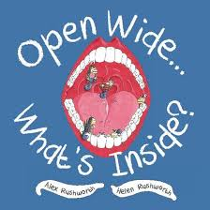    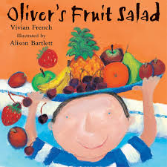  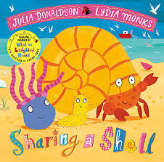  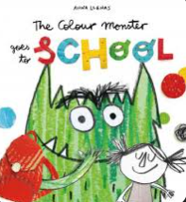
Additional Key Information
Woven throughout our curriculum are:

Characteristics of Effective Teaching and Learning: Playing and Exploring, Active Learning, Creating and thinking critically.
British Fundamental Values: democracy, rule of law, individual liberty, mutual respect and tolerance for those with different faiths & beliefs

Pencil grip 1,2,3,4
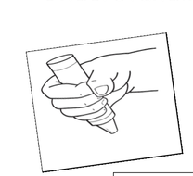 grip 1 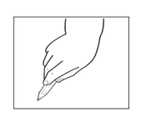 grip 2 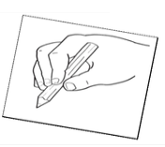 grip 3 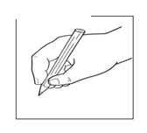 grip 4
Progression of play:
Unoccupied Play (3m -2yrs)
Movements that children make, often with no clear purpose.

Solitary Play (3m -2yrs)
Children start to play on their own. Children not seem to notice other children nearby.

Onlooker Play (2.5 yrs)
Children watch others play. The child who is looking may ask questions, but does not join in the play.

Parallel Play (2.5 – 3.5 yrs)
Children begin to play side by side, but without any interaction. They are paying attention to each other.

Associative Play (3-4 yrs)
Children start asking questions of each other. They have similar goals, but no set rules.

Social Play (4-6 yrs)
Children begin to share ideas and toys, and follow established rules.
Progression of Writing patterns:

*To support the development of pencil grip and writing patterns, we plan sequentially across the year:
Flipper Flappers,
Write Dance,
Dough Disco.

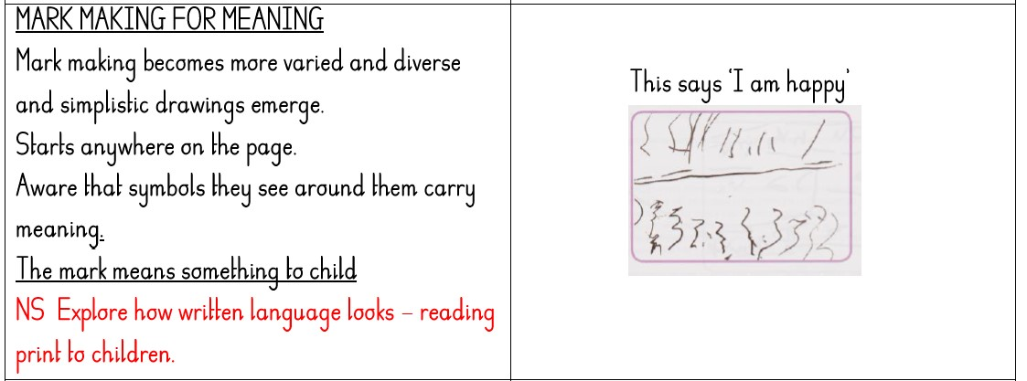
Mark making for meaning
(More varied shapes. Begin to say what they have written.)

Initate a vertical line and horizontal line.
2.5 yrs
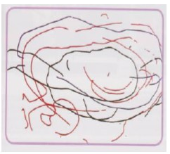
Preliterate mark making
(No intentional meaning)

Random and spontaneous in vertical, horizontal and circular motions.
2 yrs
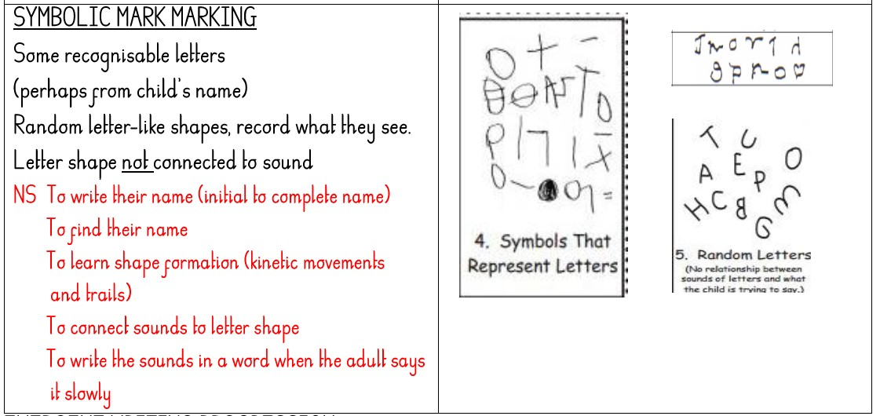Symbolic mark making
(Attempting letter like shapes, but not linking to sounds.)
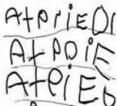Emergent writing
(Symbols they know the sounds they make. Mostly from name.)

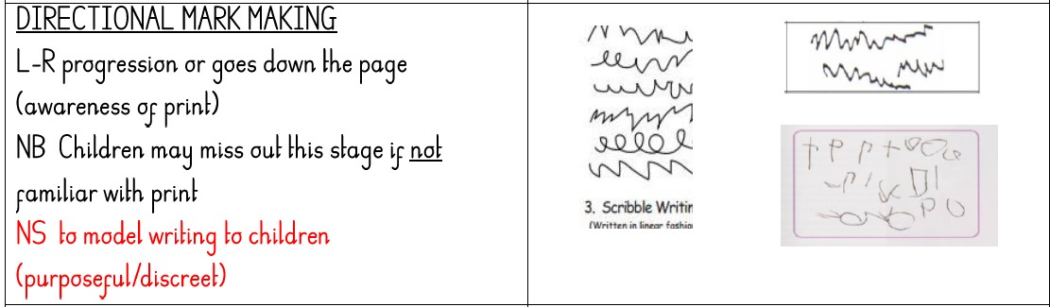Directional mark making
(Shapes that may be written across the page.)

Progression of Scissor/Cutting Skills:

2 Years  Approximate age | Cutting dough/ cooked pasta | 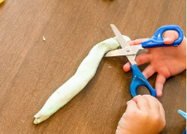
2.5 Years  Approximate age | Cutting snips on paper | 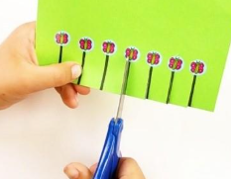
3 Years  Approximate age | Cutting a straight line | 
3.5 Years  Approximate age | Cutting a curve line or circle | 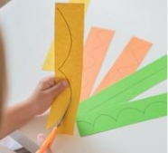
4 + Years  Approximate age | Cutting a square | 
Progression of Scissors:
Plastic Playdough Scissor | 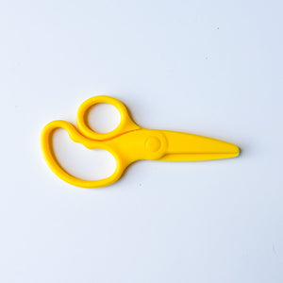
Loop Scissor | 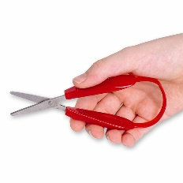
Spring Back Scissor | 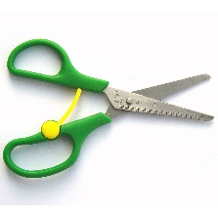
4 Holed Scissor | 
Non-spring Scissor | 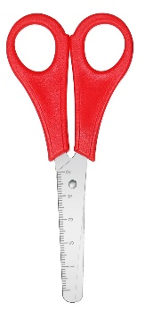
Patterned Scissor | 