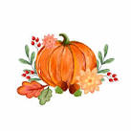
Half Term Hunt
During the half term holiday, we wonder if you would like to do some of these fun activities!

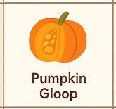
Pumpkin Gloop
Can you scoop out the inside of a pumpkin and explore the seeds and stringy texture?
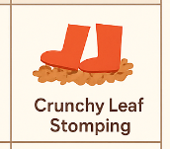
Can you collect some dry leaves to walk, stomp, or roll in? How did the leaves feel?

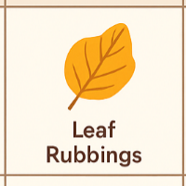
Can you do some leaf Rubbings with some large crayons or coloured pencils?

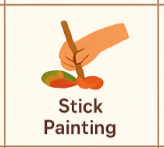
Can you do some stick Painting with some coloured water?

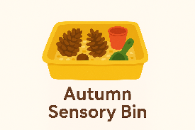
Can you make an Autumn Sensory tub? Fill a tub with natural items like pinecones, acorns (safe size only), crunchy leaves, and conkers? You can use some scoops, cups, and small spoons for pouring and digging.
You can take a photograph or bring in your objects into Nursery to share.
Have fun!

