
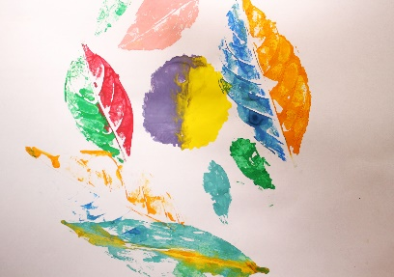
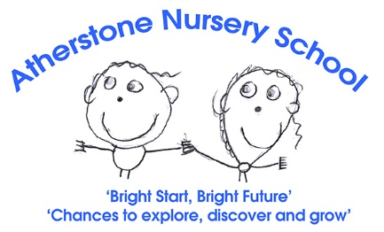
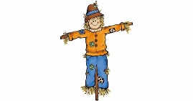
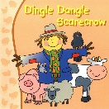
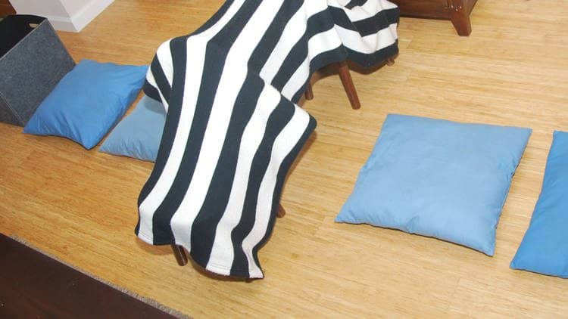
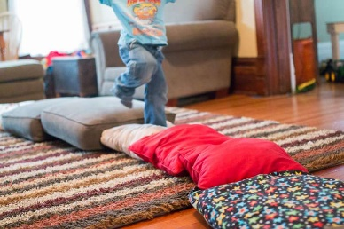
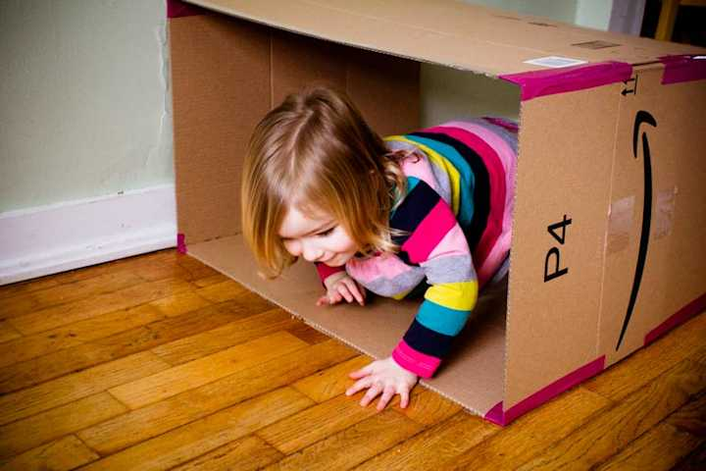
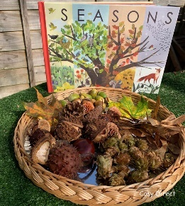
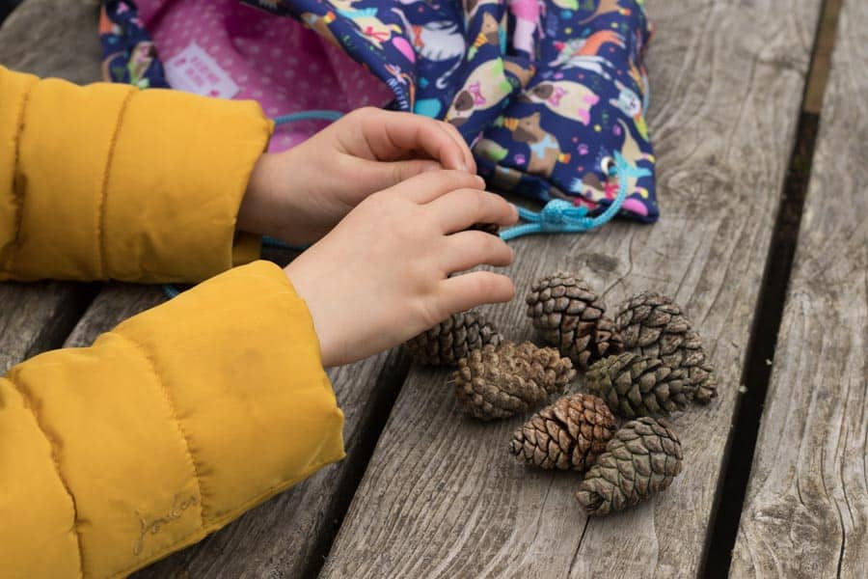
Caterpillar Home Learning

-

-

Let's try leaf printing! Collect some leaves when you go on your walk, paint them with different colours and then press the painted side onto paper to create a beautiful imprint, or you could arrange the leaves into a pattern.

Can you sing this action song, ‘The Dingle Dangle Scarecrow’

Dingle Dangle Scarecrow
When all the cows were sleeping and the sun had gone to bed Up jumped the scarecrow and this is what he said,
‘I’m a dingle dangle scarecrow with a flippy floppy hat, I can shake my hands like this and shake my feet like that.’
When all the hens were roosting and the moon’s behind a cloud, Up jumped the scarecrow and shouted very loud ‘I’m a dingle dangle scarecrow with a flippy floppy hat, I can shake my hands like this and shake my feet like that.’
Homemade obstacle course: Can you gather some cushions, pillows and maybe some boxes to create a simple obstacle course in your living room. You can, crawl under, climb over, and balance along the course.

Nature basket: Can you collect some leaves, conkers or pinecones, when you go on a walk? When you get home you can explore the different colours, sizes and textures.

