
Half Term Hunt
During the half term holiday, we wonder if you would be able to go on a hunt with your grown up, wherever you maybe. On your hunt, you will need to do some good looking!
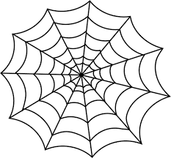
Can you find 1 spider web?

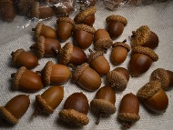
Can you find 2 acorns?

Can you find 3 trees?
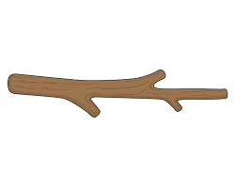
Can you find 4 sticks?

Can you find 5 leaves?


How many pumpkins can you see?

Did you see any squirrels or birds? How many?


You can take a photograph or bring in your objects into Nursery to share. Have fun!

